5pc Plastic Garden Hose Fitting Set

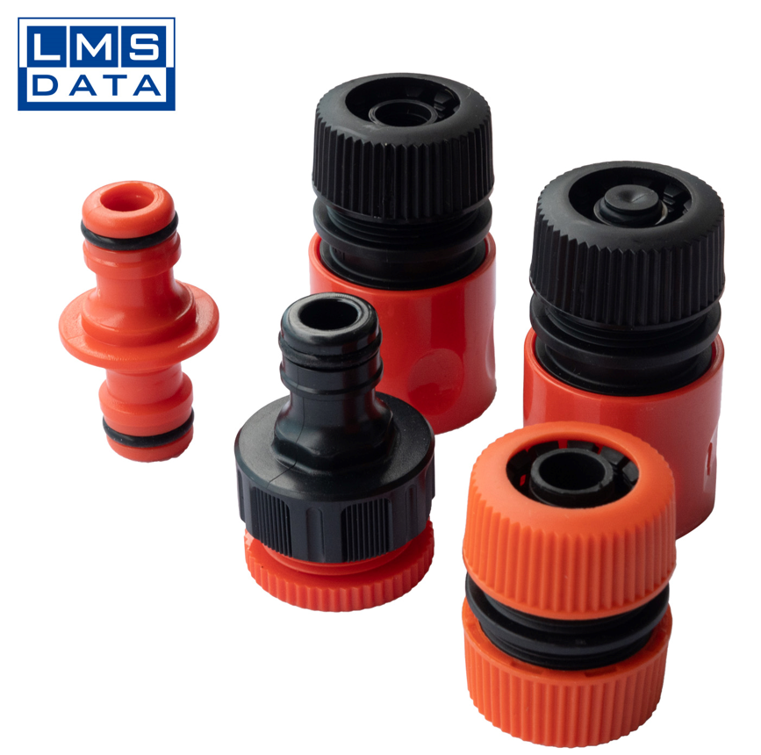

- WEATHER AND SHATTER PROOF!!

- Packaging includes:
1 x 1/2" Hose Connector
1 x 1/2" Hose Connector with stop
1 x 1/2" & 3/4" Thread 2 in 1 Tap Female Adapter
1 x 1/2" Repair/Mender Connector
- 1 x Double quick Hose Connector

- Part number: LMS505004
- Barcode number:8400800041128

